Original version: Find-it type 1, v 3.1.4a by Michael Rottmeier (2004)
modified by Agnès Simonet for v 5.0.1 (2020) November 2020

Find-it type 1
FIa_501
(for Hot Potatoes v 7)
Michael Rottmeier’s add-on

The examples in this tutorial are for version 5.0.1.
You can easily adapt them for other versions (5.0.2 etc.)

I What is a Find-it type 1 exercise?
It's a JCloze exercise where the student has to detect words (or phrases) in a text.
These words can be correct words, extra-words or incorrect words.
As soon as the student detects the words, the correction is displayed, if necessary.
If you want the student to make the correction himself, use Find-it type 2 (FIb_501).

Examples (see the demo files):
- Find the adjectives in a text [FIa_501_demo0b.htm].
- Find the incorrect words in sentences [FIa_501_demo0a.htm and FIa_501_demo1.htm].
- Find the extra words which don't fit in with the sense of a text [FIa_501_demo_2.htm].

II What is new in the 5.0.1 version ?
- The version 3.1.4 has been updated for Hot Potatoes v7.0.
- As some customization items have been diverted from their original purposes by Michael Rottmeier, it can be difficult to know where and what to write in the customization windows. So special interface files has been written.
- In the original version when the student had clicked on a word to be detected, the word was immediately replaced by the bolded correct word. Two others types of display have been added, with colors.
- The feedbacks have been modified .

III How do I install Find-it type 1?
Unzip Find_It_501a.zip and copy the FIa_501 folder where you want, for example in the source folder of Hot Potatoes.
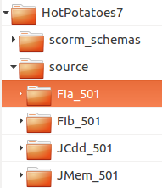
Note: you can copy the folder anywhere on your hard disk and rename it as you like.
Verify that the demos, hif and source folders are present:
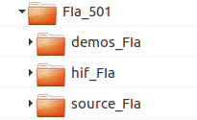

IV How do I create a Find-it type 1 exercise and HTML page ?
The main things to keep in mind:

- In the main window of JCloze you enter your text as usual with the correct words.

- The incorrect word(s)* which will appear in the exercice are defined in the "Gapped word alternatives" window.
* the "incorrect" words are sometimes the same as the "correct" words [see demo0b or demo2]

- Before exporting an HTML page: CTRL+ALT+SHIFT+S to choose the source files of FIa_501.

V Load the interface file
You don't necessarily have to do it but if you load the interface file associated with Find-it it will be easier for you to create your exercise and change the configuration output.
Open JCloze. Click on Options->Interface->Load interface file.
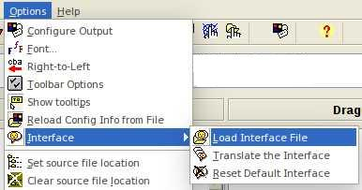
Browse to the folder FIa_501/hif_FIa/ and choose the Find_it_501a_en.hif (or Find_it_501a_de.hif, Find_it_501a_dk.hif, Find_it_501a_fr.hif) file.
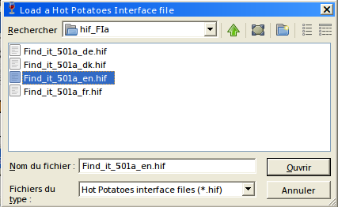
In the FIa_501/hif_FIa folder you will not find all the existing hif. You will find them, if they exist, on the hpaddons site.
You can add the translation in your language, if it does not exist, on the Paolo Cutini’s site or contact me on the hotpotusers google group.
A dialogue box will ask you if you would like to change the interface for all applications. Choose “No“.
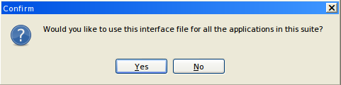

You will immediately notice the changes (here with Find_it_501a_en.hif):
original interface new interface
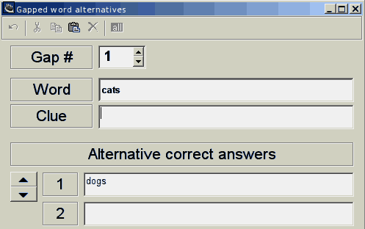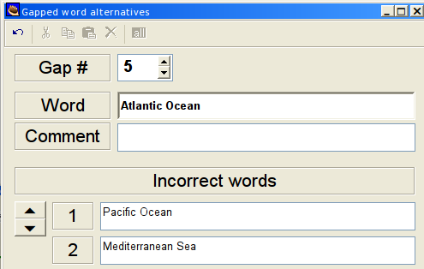

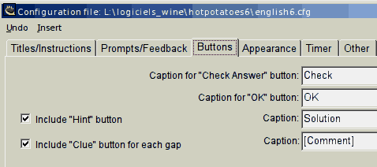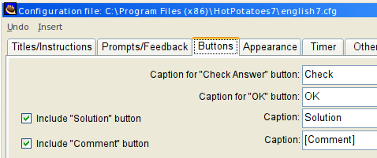

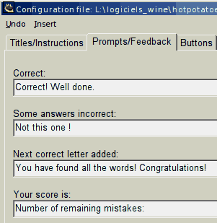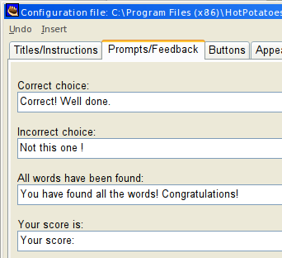

VI Different displays after a click on a word to be detected
You can choose the kind of display in Options>Configuration output>Custom:
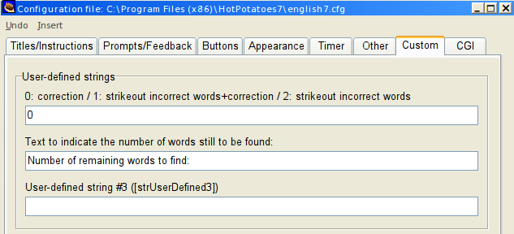
Type 0, 1 or 2 in the box.
There are three possibilities:
- 0: Default mode
The correction of the clicked word appears in color (green in the demo). The correction of the undetected words appear in another color (blue in the demo) when the Solution button is clicked.
This is the display used in the original version, though with no colors.

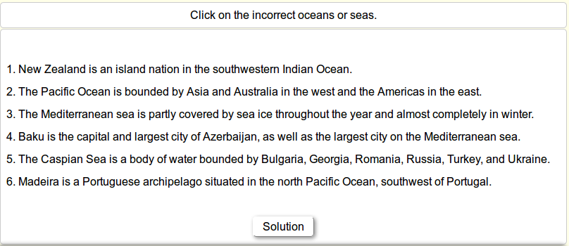
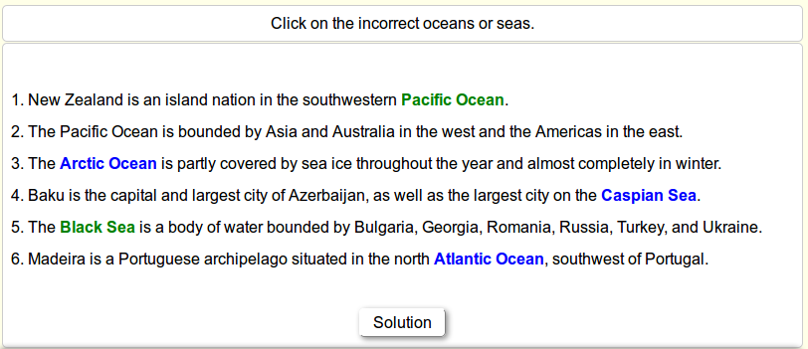

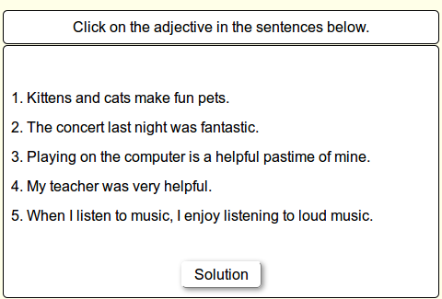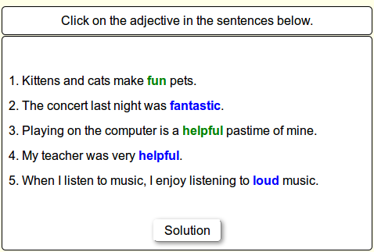
In the above exercise the "incorrect" words are the same as the "correct" words.

- 1: the clicked words appear in color (orange in the demo) with a line through. Next to them the correct words are written (in green in the demo). The undetected words appear in another color (red in the demo) when the Solution button is clicked.
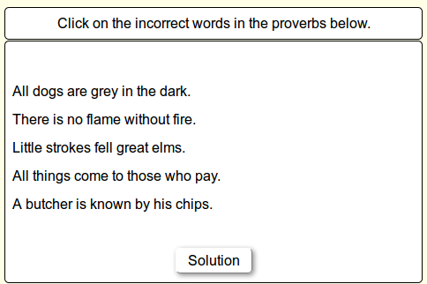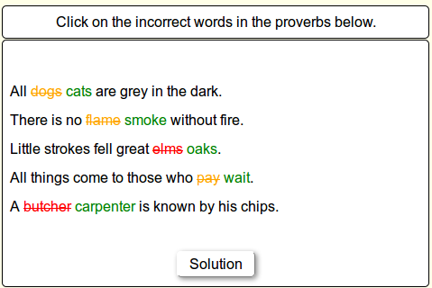

- 2: the clicked words appear in color (orange in the demo) with a line through. The undetected words appear in another color (red in the demo) when the Solution button is clicked.
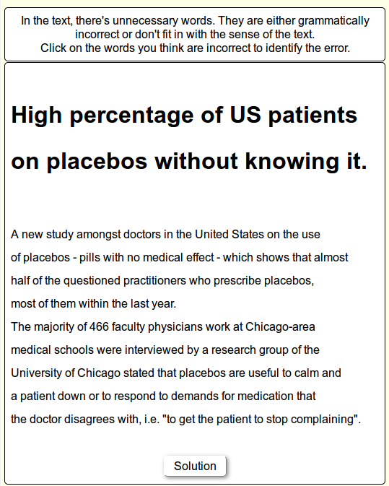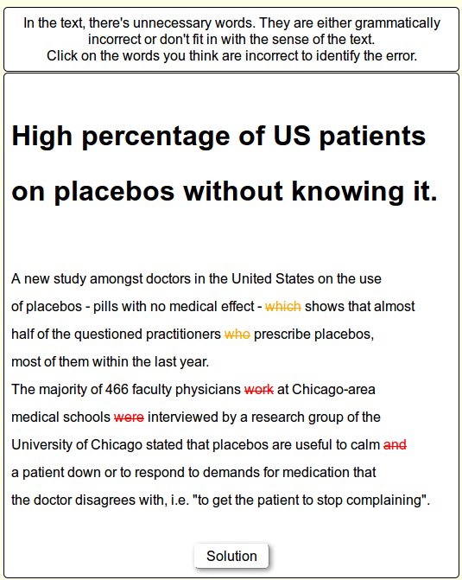

VII How to choose the colors
Those colors are defined in jcloze7.ht_, near line 47.
To modify them you need to open jcloze7.ht_ with a good text editor (not a word processor - use Notepad++, gedit or something decent like that).

.GapSpanFoundError {
font-weight: normal;
color: orange;
text-decoration:line-through;
}

.GapSpanNotFoundError {
font-weight: normal;
color: red;
text-decoration:line-through;
}

.GapSpanCorrection {
font-weight: normal;
color: green;
text-decoration:none;

}

.GapSpanDetected {
font-weight: bold;
color: green;
text-decoration:none;
}

.GapSpanUnDetected {
font-weight: bold;
color: blue;
text-decoration:none;
}

You can find the names or the HTML hexadecimal codes for colors on wikipedia.

VIII Comments
You can add a comment for a solution.
This functionnality is optional.
Portugal is bordered by the Atlantic Ocean to the west.

As soon as the word is found a button [Comment] will be displayed.
If the student click on the Comment button, the comment will be displayed in the feedback window.
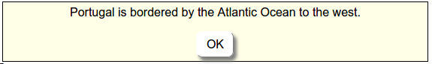

IX Feedbacks
- When you click on a word to be detected:
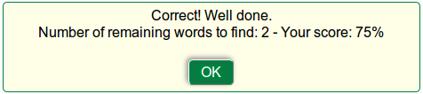

- When you click on the Solution button:
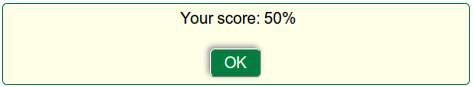
- "Correct! Well done." and "Your score:" can be modified using Options>Configure output>Prompts/Feedbacks.

- "Number of remaining words to find:" can be modified using Options>Configure output>Custom.

